ABSTRACT

Question answering (QA) is a popular researched problem in natural language processing. QA has been used to develop dialog systems and chatbots designed to simulate human conversation. Here we researched two different models for QA system.

First, we researched a learning model called memory networks. Memory networks reason with inference components combined with a long-term memory component; they learn how to use these jointly. The long-term memory can be read and written to, with the goal of using it for prediction. We investigate these models in the context of question answering (QA) where the long-term memory effectively acts as a (dynamic) knowledge base, and the output is a textual response.

Second, based on memory networks, we implemented a neural network with a recurrent attention model over a possibly large external memory. The architecture is a form of Memory Network but unlike the model in that work, it is trained end-to-end, and hence requires significantly less supervision during training, making it more generally applicable in realistic settings.

We evaluate them on a large-scale QA task, and a smaller, but more complex, toy task generated from a simulated world. In the latter, we show the reasoning power of such models by chaining multiple supporting sentences to answer questions that require understanding the intentions of verbs.

RELATED WORK

Several projects targeting language understanding using QA-based strategies have recently emerged. Unlike tasks like dialogue or summarization, QA is easy to evaluate (especially in true/false or multiple-choice scenarios) and hence makes it an appealing research avenue. The difficulty lies in the definition of questions: they must be unambiguously answerable by adult humans (or children), but still require some thinking. The Allen Institute for AI’s flagship project ARISTO1 is organized around a collection of QA tasks derived from increasingly difficult science exams, at the 4th, 8th, and 12th grade levels.

Richardson et al. (2013) proposed the MCTest2 a set of 660 stories and associated questions intended for research on the machine comprehension of text. Each question requires the reader to understand different aspects of the story.

Conclusions drawn from these projects are not much clearer than that coming from more traditional works on QA over large-scale Knowledge Bases (Berant et al., 2013; Fader et al., 2014). Besides, the best performing systems are based on hand-crafted patterns and features, and/or statistics acquired on very large corpora. It is difficult to argue that such systems actually understand language and are not simply light upgrades of traditional information extraction methods (Yao et al., 2014). The system of Berant et al. (2014) is more evolved since it builds a structured representation of a text and of a question to answer. Despite its potential this method remains highly domain specific and relies on a lot of prior knowledge.

Based on these observations, we chose to conceive a collection of much simpler QA tasks, with the main objective that failure or success of a system on any of them can unequivocally provide feedback on its capabilities. In that, we are close to the Winograd Schema Challenge Levesque et al. (2011), which is organized around simple statements followed by a single binary choice question such as: “Joan made sure to thank Susan for all the help she had received. Who had received the help? Joan or Susan?”.

OUR APPROACH

We utilize a novel recurrent neural network (RNN) architecture where the recurrence reads from a possibly large external memory multiple times before outputting a symbol. The model can be considered a continuous form of the Memory Networks. The continuity we present means that it can be trained end-to-end from input-output pairs, hence requires significantly less supervision during training, making it more generally applicable in realistic settings and to more tasks.

The model takes the set of inputs and stores it in the memory. The question as another input from the user and the answer of the question as output. The model writes all the inputs in the memory up to a fixed buffer size and then it finds a continuous representation for the inputs and the

question. The continuous representation is then processed with many repetitions to get the answer as output. This allows back-propagation of the error signal through multiple memory accesses back to the input during training. We start by describing our model in the single layer case, which implements a single memory hop

operation. We then show it can be stacked to give multiple hops in memory to handle K hop operations.

DATASET

The quest for knowledge is deeply human, and so it is not surprising that practically as soon as there were computers, and certainly as soon as there was natural language processing, we were trying to use computers to answer textual questions. In this project, we have taken the Babi dataset to implement the Question Answering System and know how to it works in detail. The Facebook bAbI dataset is a synthetic dataset of 20 question-answering tasks. Each task targets a specific skill that a general reasoning agent would be expected to have, such as answering yes/no questions or performing deduction over multiple sentences.

**Training Set Size:** Each of the 20 tasks consists of 1,000 training examples and 1,000 test examples. The tasks are generated from a simulation of characters and objects interacting in a small, closed world, which produces ground text describing the scene and question/answer pairs.

Supervision is provided in the form of answers for each of the questions and the location of relevant sentences in the input required to answer the question. For development, we randomly partition the 1,000 training examples for each task into 900 example training sets and 100 example development sets. To answer the questions correctly, the models must be able to perform induction, deduction, fact chaining, and more. The dataset presents tasks for testing text understanding and reasoning.

The aim is that each task tests a unique aspect of text and reasoning, and hence test different capabilities of learning models. All of the tasks are noiseless and a human able to read that language can potentially achieve 100% accuracy. The data itself is produced using a simple simulation of characters and objects moving around and interacting in locations.

The file format for each task is as follows:

ID text

ID text

ID text

ID question[tab]answer[tab]supporting fact IDS.

...

The IDs for a given “story” start at 1 and increase. When the IDs in a file reset back to 1 you can consider the following sentences as a new “story”. Supporting fact IDs only ever reference the sentences within a “story”.

Described below are different types of tasks in our dataset:

**Single Supporting Fact:** Task 1 consists of questions where a previously given single supporting fact, potentially amongst a set of other irrelevant facts, provides the answer.

**Two or Three Supporting Facts:** A harder task is to answer questions where two supporting statements have to be chained to answer the question.

**Two or Three Argument Relations:** To answer questions the ability to differentiate and recognize subjects and objects is crucial. In task 4 we consider the extreme case where sentences feature reordered words, i.e. a bag-of-words will not work.

**Yes/No Questions:** Task 6 tests, on some of the simplest questions possible (specifically, ones with a single supporting fact), the ability of a model to answer true/false type questions like “Is John in the playground?”.

**Counting and Lists/Sets:** Task 7 tests the ability of the QA system to perform simple counting operations, by asking about the number of objects with a certain property, e.g. “How many objects is Daniel holding?”.

**Simple Negation and Indefinite Knowledge:** Tasks 9 and 10 test slightly more complex natural language constructs. Task 9 tests one of the simplest forms of negation, that of supporting facts that imply a statement is false.

**Basic Coreference, Conjunctions and Compound Coreference:** Task 11 tests the simplest type of coreference, that of detecting the nearest referent, e.g. “Daniel was in the kitchen. Then he went to the studio.”

**Time Reasoning:** While our tasks so far have included time implicitly in the order of the statements, task 14 tests understanding the use of time expressions within the statements.

**Basic Deduction and Induction:** Task 15 tests basic deduction via inheritance of properties, e.g. “Sheep are afraid of wolves. Gertrude is a sheep. What is Gertrude afraid of?”.

**Positional and Size Reasoning Task:** 17 tests spatial reasoning by asking questions about the relative positions of colored blocks.

**Path Finding:** The goal of task 19 is to find the path between locations: given the description of various locations, it asks: how do you get from one to another?

**Agent’s Motivations:** Finally, task 20 questions, in the simplest way possible, why an agent performs an action. It addresses the case of actors being in a given state (hungry, thirsty, tired, . . .) and the actions they then take, e.g. it should learn that hungry people might go to the kitchen, and so on.

MODEL

Memory Networks

Memory Networks combine inputs with attention on memories to provide reasoned outputs. Limits the first iteration’s scope to be as simple as possible. It consists of a recurrent controller module that accepts an initial query. To start, its memory is loaded with a set of facts. The query and facts are bag-of-words vectors. The controller predicts an attention vector (with a supervision signal) to choose a fact. It reads the chosen memory to update its hidden state. After several repetitions, or hops, it formulates an output. The output ranks possible responses from a dictionary of words. Error signals back-propagate through the network via the output and the supervised attention

episodes.



Fig 1: Explains the End to End Memory Network with n hops

Each benchmark consists of a set of short stories. Each story is a sequence of statements about an evolving situation. The model should read a single story and answer one or more questions about it. Within a benchmark, the stories test the same skill. Across the different benchmarks, the skills get more difficult.

Example –

* John was in the bedroom.
* Bob was in the office.
* John went to the kitchen.
* Bob travelled back home.
* Where is John? A: kitchen
* Factoid question/answer with single supporting fact
* Factoid QA with two supporting facts
* Factoid QA with three supporting facts
* Two argument relations: subject versus object
* Three argument relations
* Yes/no questions
* Counting
* Lists/sets
* Simple negation
* Indefinite knowledge
* Basic coreference
* Conjunction
* Compound coreference
* Time manipulation
* Basic deduction

End-to-end Memory Network (MemN2N) learns without attention supervision. It uses soft attention (a probability vector) to read the memory. Thus, it is fully-differentiable and can learn from output supervision alone. The newer model still fails on some toy benchmark tasks. Yet, it succeeds on several real-world benchmarks, such as children’s books and news question sets.



Fig 2: 4 steps of MemNN implementation

* I (input): converts to word embeddings X(dialog).
* G (generalization): stores x in next available slot Mn()
* (output): Loops over all memories k=1 or 2 times:
* 1st loop max: finds best match Mi with X(question)
* 2nd loop max: finds best match Mj with (x, Mi)
* The output o is represented with (x, Mi, Mj).
* R (response): ranks all words in the dictionary given O and returns best single word.

DATA ANALYSIS

Document Clustering with Python

Nltk –

NLTK is a leading platform for building Python programs to work with human language data. It provides easy-to-use interfaces to over 50 corpora and lexical resources such as WordNet, along with a suite of text processing libraries for classification, tokenization, stemming, tagging, parsing, and semantic reasoning, wrappers for industrial-strength NLP libraries.

NLTK has been called “a wonderful tool for teaching, and working in, computational linguistics using Python,” and “an amazing library to play with natural language.”

Clustering text documents using k-means

This is an example showing how the scikit-learn can be used to cluster documents by topics using a bag-of-words approach. This example uses a scipy-sparse matrix to store the features instead of standard numpy arrays.

Two feature extraction methods can be used in this example:

• Tfidf Vectorizer uses an in-memory vocabulary (a python dict) to map the most frequent words to features indices and hence compute a word occurrence frequency (sparse) matrix. The word frequencies are then reweighted using the Inverse Document Frequency (IDF) vector collected feature-wise over the corpus.

• Hashing Vectorizer hashes word occurrences to a fixed dimensional space, possibly with collisions. The word count vectors are then normalized to each have l2-norm equal to one (projected to the Euclidean unit-ball) which seems to be important for k-means to work in high dimensional space.

Hashing Vectorizer does not provide IDF weighting as this is a stateless model (the fit method does nothing). When IDF weighting is needed it can be added by pipelining its output to a TfidfTransformer instance.

Two algorithms are demoed: ordinary k-means and its more scalable cousin minibatch k-means.

Note: as k-means is optimizing a non-convex objective function, it will likely end up in a local optimum.

Several runs with independent random unit might be necessary to get a good convergence.

Analysis has been done using the following Steps:

• Stop words, stemming, and tokenization

• Tf-idf and document similarity

• K-means clustering

• Multidimensional scaling

• Visualizing document clusters

• Hierarchical document clustering

• Latent Dirichlet Allocation (LDA)

**Functions used for clustering:**

tokenize_and_stem: tokenizes (splits the text into a list of its respective words (or tokens) and also stems each token

tokenize_only: tokenizes the para only I use both these functions to create a dictionary which becomes important in case I want to use stems for an algorithm, but later convert stems back to their full words for presentation purposes.

K-means clustering: Using the tf-idf matrix, run a slew of clustering algorithms to better understand the hidden structure within the text. K-means is used. K-means initializes with a pre-determined number of clusters (I chose 5). Each observation is assigned to a cluster (cluster assignment) so as to minimize the within cluster sum of squares. Next, the mean of the clustered observations is calculated and used as the new cluster centroid. Then, observations are reassigned to clusters and centroids recalculated in an iterative process until the algorithm reaches convergence. Several runs for the algorithm to converge a global optimum as k-means is susceptible to reaching local optima.

Indexing and sorting on each cluster to identify which are the top n (I chose n=6) words that are nearest to the cluster centroid. This gives a good sense of the main topic of the cluster.



Fig 3: K-means clustering text document with labels



Fig 4: K-means clustering text document without labels

Hierarchical clustering: Now that we were successfully able to cluster and plot the documents using kmeans, we wanted to try another clustering algorithm. we chose the Ward clustering algorithm because it offers hierarchical clustering. Ward clustering is an agglomerative clustering method, meaning that at each stage, the pair of clusters with minimum between-cluster distance are merged. We used the precomputed cosine distance matrix (dist.) to dendrogram.

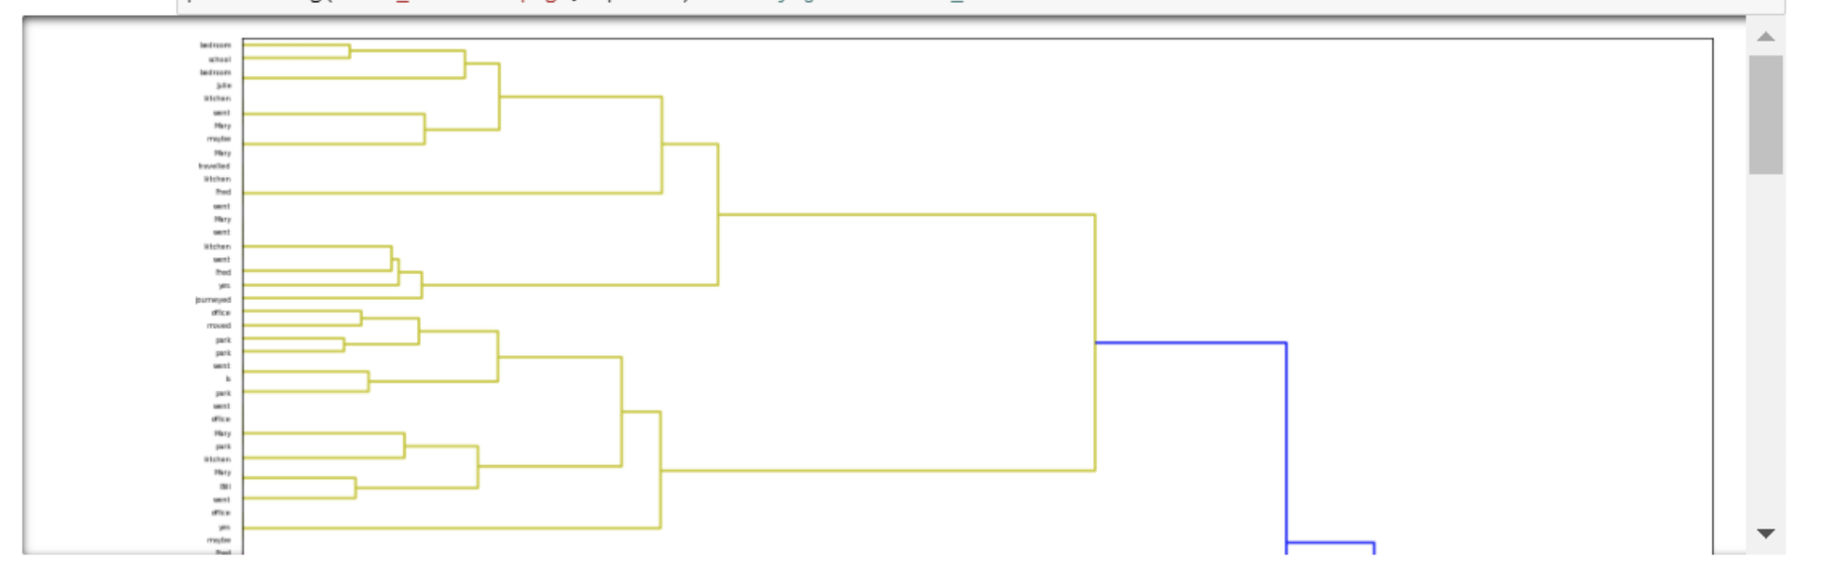

Fig 5: Dendrogram for Hierarchial clustering

Sentiment Analysis on a part of the dataset

Sentiment Analysis is the process of computationally identifying and categorizing opinions expressed in a piece of text, especially in order to determine whether the writer's attitude towards a particular topic, product, etc., is positive, negative, or neutral.

In this case, we have used Vader – SentimentIntensityAnalyzer. VADER (Valence Aware Dictionary for sentiment Reasoning) is a model used for text sentiment analysis that is sensitive to both polarity (positive/negative) and intensity (strength) of emotion.

VADER text sentiment analysis uses a human-centric approach, combining qualitative analysis and empirical validation by using human raters and the wisdom of the crowd. It combines a dictionary, which maps lexical features to emotion intensity, and five simple

heuristics, which encode how contextual elements increment, decrement, or negate the sentiment

of text.

The VADER algorithm outputs sentiment scores to 4 classes of sentiments:

• neg: Negative

• neu: Neutral

• pos: Positive

• compound: Compound (i.e. aggregated score)

Entity Extraction and Network Analysis

To extract meaningful information from raw text and use it to analyze the networks of individuals hidden within the data set. To take a set of documents (in our case, training dataset), extract entities from within them, and develop a social network based on entity document co-occurrence. This can be a useful approach for getting a sense of which entities exist in a set of documents and how those entities might be related.

The primary piece of software used is Stanford Core NLP.

Stanford Core NLP is one of the most popular natural language processing tools out there. It has a ton of functionality which includes part of speech tagging, parsing, lemmatization, tokenization, and what we are interested in: named entity recognition (NER). NER is the

process of analyzing text to find people, places, and organizations contained within the text.

These named entities will form the basis of the rest of our analysis, so being able to extract them from text is critical.

Browser go to http://localhost:9000 for the tool. We receive a set of the extracted people entities from each sentence. When a text is entered, the software it gives the output as Parts-of-Speech, named entity, dependency parse, basic and advanced dependencies for each work in the sentence.



Fig 6: Stanford NLP tool to analyze text and Parts of Speech



Fig 7: Stanford NLP tool to analyze the dependencies



Fig 8: Network Analysis Graph:

DISCUSSION

We have created a web application with our model to visualize the results we will get and predict from the model. Our viewpoint is that showing and visualizing the data and accuracy of the prediction on a web application made on flask, will give us a better idea of our model. This model can be enhanced even more if we had more random datasets to it giving it an ID so that the model can predict the effectiveness.



Fig 9: Front end web application to check the result

RESULTS

We report a variety of design choices varying memory hops from 1 to 3.

The mean performance results across all 20 tasks are given in Table 1 for the 1k training set

|  |  |  |  |
| --- | --- | --- | --- |
| Hops | 1 hop | 2 hops | 3 hops |
| Mean error (%) | 25.8 | 15.6 | 13.3 |

Table1: Shows the mean error of the 3 Hops used to train the model

CONCLUSION

In this work we showed that a neural network with an explicit memory and a recurrent attention mechanism for reading the memory can be successfully trained via back propagation on QA tasks.

Compared to the Memory Network implementation, there is no supervision of supporting facts and so the N2N MemNet model can be used in a wider range of settings. This model approaches the same performance of that model, and is significantly better than other baselines with the same level of supervision.

On QA task we can see that increasing the number of memory hops improves performance.

REFERENCES

Data:

[1] <https://research.fb.com/downloads/babi/>

Paper:

[2] MEMORY NETWORKS Jason Weston, Sumit Chopra & Antoine Bordes, <https://arxiv.org/abs/1410.3916>

[3] End-To-End Memory Networks Sainbayar Sukhbaatar, Arthur Szlam, Jason Weston, Rob Fergus, <https://arxiv.org/abs/1503.08895>

Blog:

https://blog.csdn.net/irving_zhang/article/details/79094416

https://blog.csdn.net/Irving_zhang/article/details/7911112

<https://blog.csdn.net/irving_zhang/article/details/78113251><https://github.com/carpedm20/MemN2N-tensorflow>

https://github.com/domluna/memn2n

<https://github.com/1202kbs/MemN2N-Tensorflow>

<http://neuralnetworksanddeeplearning.com/chap1.html>

<http://www.thespermwhale.com/jaseweston/icml2016/>

<http://brandonrose.org/clustering>

<http://snap.stanford.edu/proj/embeddings-www/>

APPENDIX

Results of the Model predicting the outcome of the question

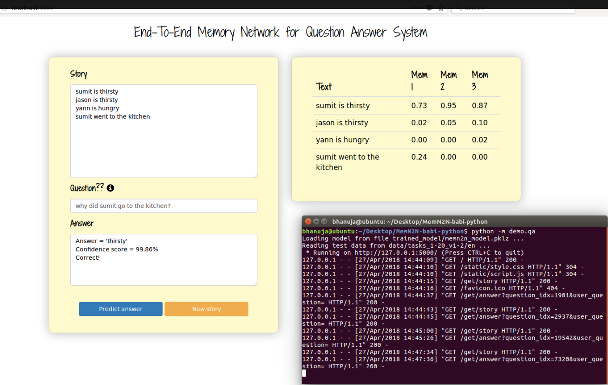

Fig1: Shows the accuracy of 99.86% - The answer to the question is correct

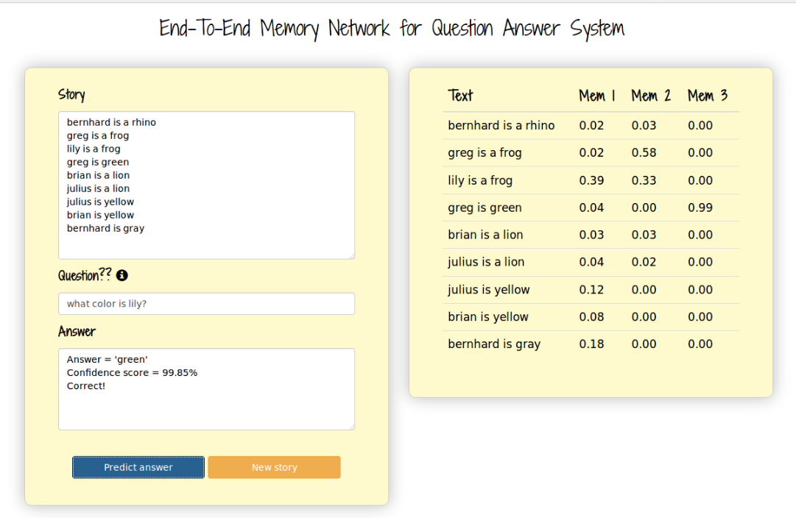

Fig2: Shows the accuracy of 99.85%

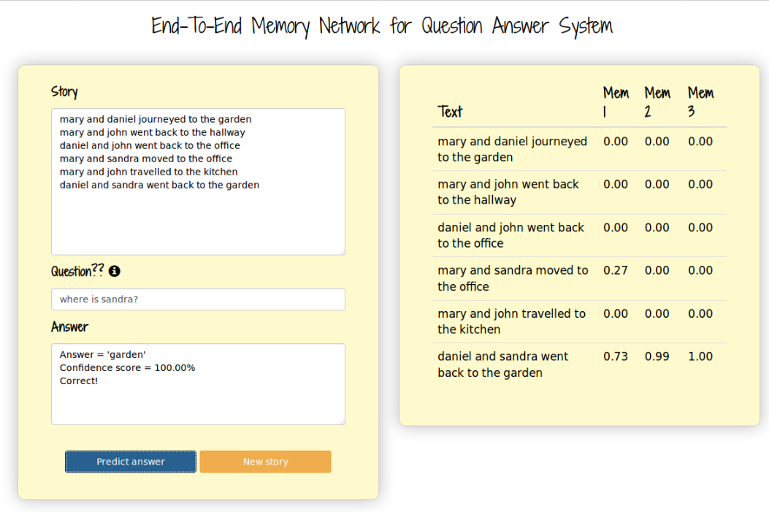

Fig3: Shows the accuracy of 100%